

Bachelor of Computer Application (BCA) Programme

Minor Project Report

BCA Sem V

AY 2022-23

*Project Title: Medical Management System*

*by*

|  |  |  |
| --- | --- | --- |
| Exam No. | Roll No. | Name of Student |
| 4064 | 037 | Devani Drashti Ghanshyambhai |

**Project Guide by :**

Prof. Nainesh sir

*I N D E X*

|  |  |  |
| --- | --- | --- |
| **Sr. No** | **Description** | **Page No.** |
| 1 | Introduction | 3 |
|  | 1.1 Project description | 3 |
|  | 1.2 Project Profile | 3 |
| 2 | Environment Description | 4 |
|  | 2.1 Hardware and Software Requirements | 4 |
|  | 2.2 Technologies Used | 4 |
| 3 | System Analysis and Planning | 5 - 7 |
|  | 3.1 Existing System and its Drawbacks | 5 |
|  | 3.2 Feasibility Study | 6 |
|  | 3.3 Requirement Gathering and Analysis | 7 |
| 4 | Proposed System | 8-10 |
|  | 4.1 Scope | 8 |
|  | 4.2 Project modules | 9 |
|  | 43 Module vise objectives/functionalities Constraints. | 10 |
| 5 | Detail Planning | 11-16 |
|  | 5.1 Data Flow Diagram / UML | 11 |
|  | 5.2 Process Specification / Activity Flow Diagram | 14 |
|  | 5.3 Data Dictionary | 15 |
|  | 5.4 Entity-Relationship Diagram / Class Diagram | 16 |
| 6 | System Design | 17-31 |
|  | 6.1 Database Design | 17 |
|  | 6.2 Directory Structure | 19 |
|  | 6.3 Input Design | 21 |
|  | 6.4 Output Design | 29 |
| 7 | Software Testing | 32 |
| 8 | Limitations and Future Scope of Enhancements | 33 |
| 9 | References | 34 |

1. **Introduction :**

**1.1 Project Description :**

The purpose of the project “**MEDICAL** **MANAGEMENT** **SYSTEM**” , the manual work

makes the process slow and other problems such as sales report on **operations**.

In order to avoid this medical management system is proposed, where the all data

information in the medical store with regard supplier is managed efficiently. It intends to

help fast in **fast access** procedures in billing details related activities and ensures to

maintain the details of the admin. Also, admin logging should be able to upload their

personal **information**. The key feature of this project is that it is one time registration

enabled.

This is a **Medical Management System**. This was developed using **PHP**and **MySQL**

**Database**. The system manages the **Pharmacy's Sales transaction** with their customers

and also **manages**their **medicinal products stocks**. The system stores the products along

with some details such as the supplier and the product categories. The product categories

are dynamically stored in the database which means the category options have a front-end

managing feature to allow the system admin manage the list of options. The system also

ounts the product availability in each category and also generates a printable sales report.

Moreover, there are more functionally.lastly, admin can seen every data of the system.

**1.2 project profile :**

* **Definition of project : online medical management system is used to admin can handle everything regarding to there medicine and suppliers.**
* **Product/Inventories Crud**
* **Sales**
* **Bill Print**
* **Discounts**
* **Reports**
* **Admin Login & Profile Update**
* **Site Setting dynamic Project Name**
* **Login & Sessions**

1. **Environment Description :**

**2.1 Hardware and Software Requirements :**

* Hardware :
* Os : windows,mac,linux
* Processor : x86 or x64
* Hard disk : up to 200 MB
* RAM : 1GB
* Software :

* Vs code , notepad ++
* Xammp
* Web browser - chrome

**2.2 Technologies Used :**

* Front-end languages :

* HTML
* CSS
* Java script
* Bootstrap

* Back-end languages :

* PHP
* MYSQL database

1. **System Analysis and Planning :**

**3.1 Existing System and its Drawbacks :**

The existing Medical Store System is manual system.The main drawback of the existing

system is time consumption. There are number of records and hence a larger number of

registers have to be kept to the store.

This document required more storing space, more manpower and job become tedious.

In Existing system following points are observed:

chances of errors and data processing time

Timely Due to manual process, required more time to complete user requirement

It will increase updating is complicated.

Security of data were not maintain

* Drawbacks :

The existing of Medical Store System is manually which require more paper work so it needs

to computerized the system to get following benefits.

Computer enhances easy and simple means of Storing information. The space occupied for

storing of information is reduced.

Computers helps in fast retrieval of information .we can search information in a short of time.

Maintenance of data is very easy and workload is reduced.

It’s a paperless system.

We can generated report on demand.

It will give faster modification.

**3.2 Feasibility Study :**

* **Technical feasibility**

Customer the work for the system can be done with the present equipment and three is no

need of other technologies so this application is technically feasible.

* **Economic feasibility**

All software packages are available or already exist in the company and institute so this

system is economically feasible.

* **Operation feasibility**

System will be use immediate because all staff is aware of how to operate so there is no need

to train them, so it is operationally feasible for the company and institute. At the end of

investigation it is found that this system is feasibly in all points of view.

* **Schedual feasibility**

It is a measure of how reasonable the project timetable .

* **Implementation feasibility**

As far the Implementation is concerned, there would not be any problem. All the user of it gets

its service by only operate this system.

**3.3 Requirement Gathering and Analysis :**

We are overcoming the difficulty of medical admin detailed which were manual in the

current system and here we generate detailed information about the medicine which

will save our time to inform each and every detail section and user profile is maintained.

**1. Functional Requirement :**

This section describes the functional requirements of the system for those requirements

which are expressed in the natural language style. A admin should be able to login to the

system through the first page of the application, and mentioned his required medicine and

he should get the details of the inventorys with that report. An also can login into his

account and he will update the all information.

**2. Non – Functional Requirement :**

* Usability :

This section includes all of those requirements that effect usability. We get the response

within seconds. The software must have a simple, user – friendly interface so customers

can save time and confusion.

* Reliability :

The system is more reliable because of the qualities that are inherited from the chosen

platform java. The code built by using java is more reliable.

* Supportability :

The system is designed to be the cross platform supportable. The system is

supported on a wide range of hardware and any software platform which is having JVM

built into the system

* Implementation :

The system is implemented in web environment. The apache tomcat is used as

the web server and windows XP professional is used as the platform.

* Interface :

The user interface is based on the web browser. The application is developed using JSP

and HTML along with DHTML. The Interface design is aimed at a flexible front – end

communication to provide the user with clear information in navigating a user – friendly

interface is planned.

**3. Performance Requirements :**

The completely separate business logic at server side from the medicine interface ensures

good performance. The system exhibits high performance because it is well

optimized. The business logic is clearly separate from the UI. We get the response within

seconds.

**4. Proposed System :**

**4.1 Scope :**

Our Project has big scope to do. We can help collecting perfect management in details. In a

very short time, the collection will be obvious, simple and sensible. It will help a person to

know the management of medicine and inventory. It also helps in current all works relative to

medical management system. It will be also reduced the cost of collecting the management

and collection procedure will go on smoothly. Various product are accessed the information

and can update it. Also, admin can add new items and its add to new inventory.

**4.2 Project modules :**

The Medical Management system has provides only for one module is Admin.

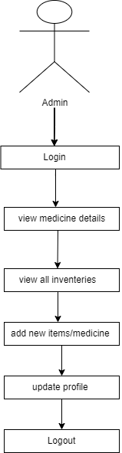

**4.3 Module vise objectives/ functionalities Constraints :**

**Admin :**

The Admin in the medical management system who views the suppliers details and medicine

details and add new items and show report and site settings , profle setting , account setting and

lastly , login and logout is the main features of the medical management system.

Additionally, when admin show medicine so at that time they can show who is this supplier and

Its full details .also,they can seen that Stock is available or not.last but not least, they can add new

Inventories .as well as they can unloading medicine picture.

**5. Detail Planning :**

**5.1 Data Flow Diagram :**

**= 0 level DFD :**

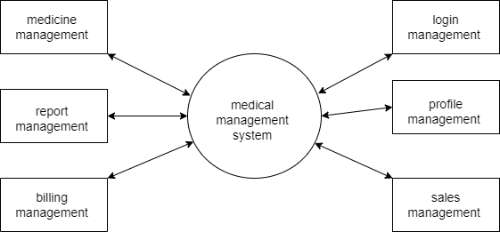

**= 1 level DFD :**

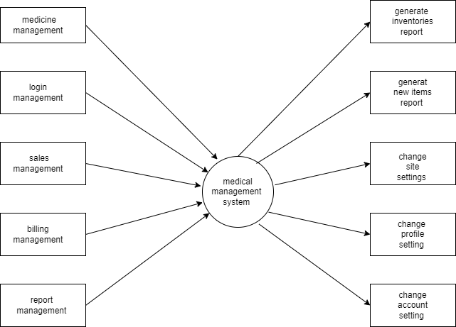

**= 2 level DFD :**

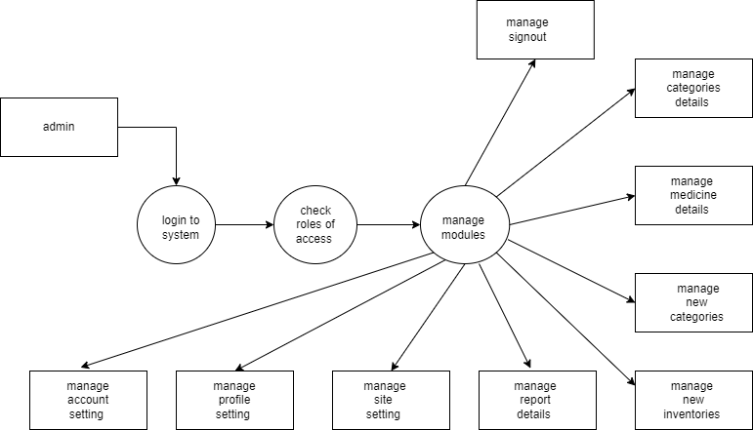

**5.2 : Process Specification / Activity Flow Diagram :**

**= Activity flow diagram :**

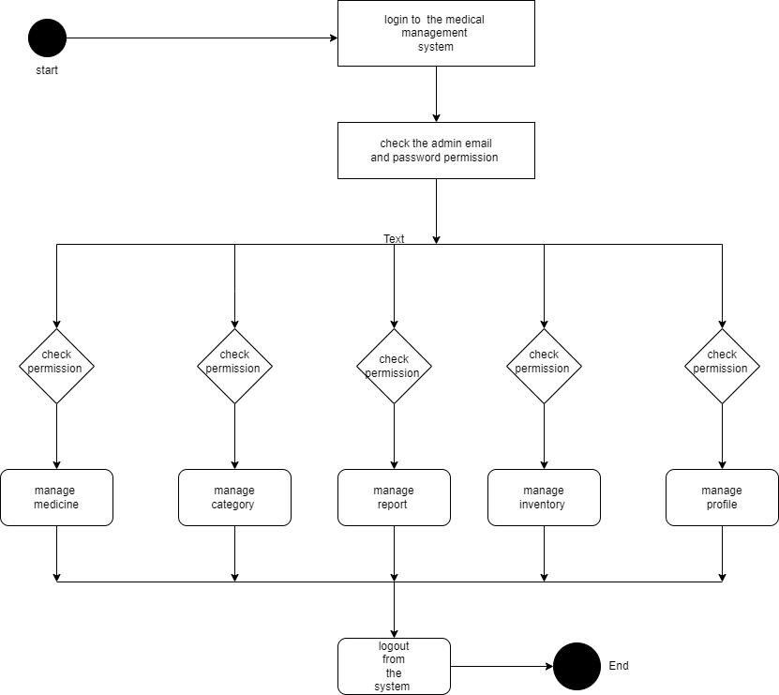

**5.3 : Data Dictionary :**

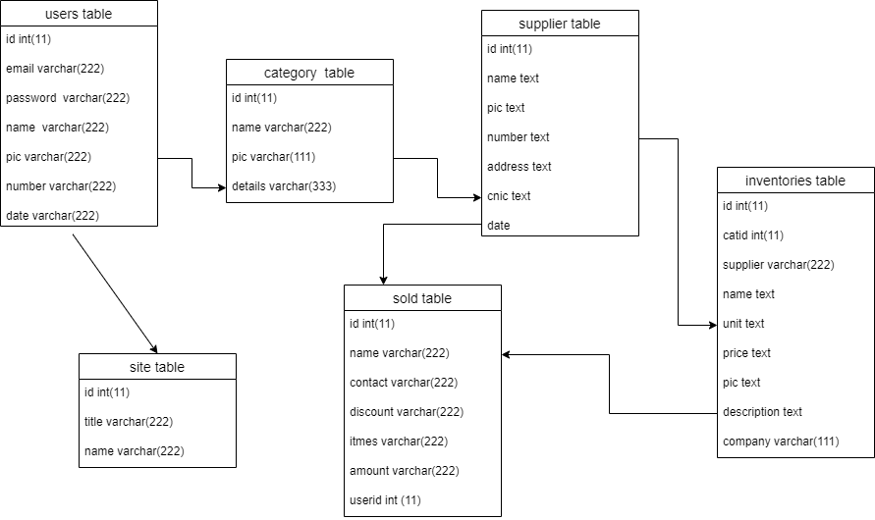

**5.4 Entity-Relationship Diagram / Class Diagram**

**= ER diagram :**

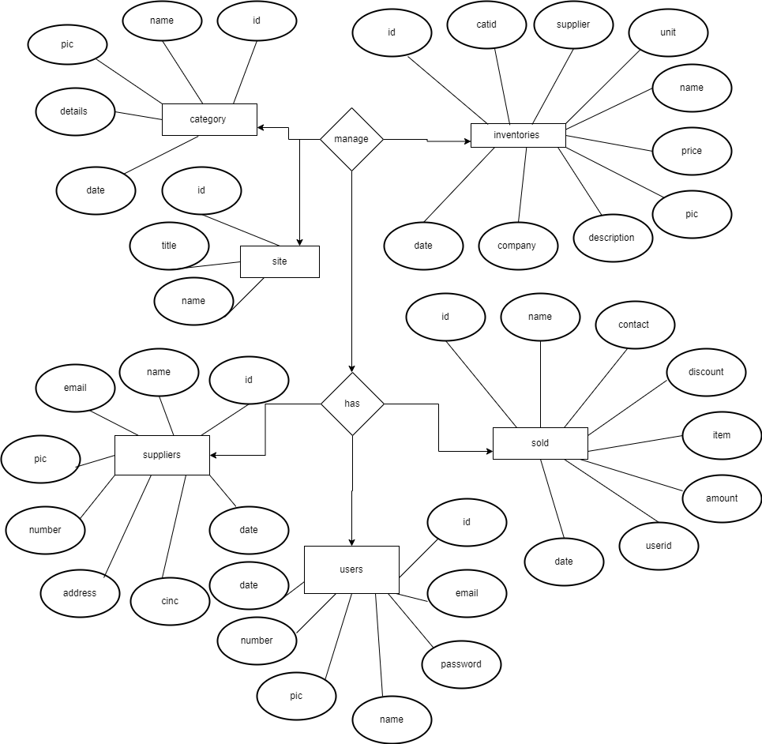

**6. System Design :**

**6.1 database design :**

= categories table :

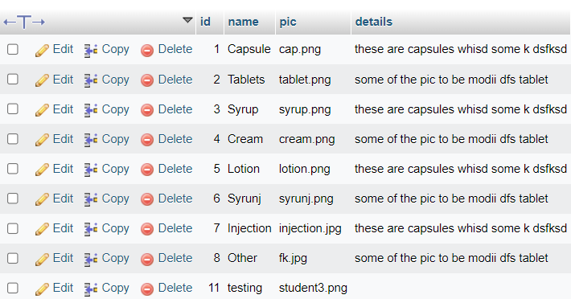

= inventories table :

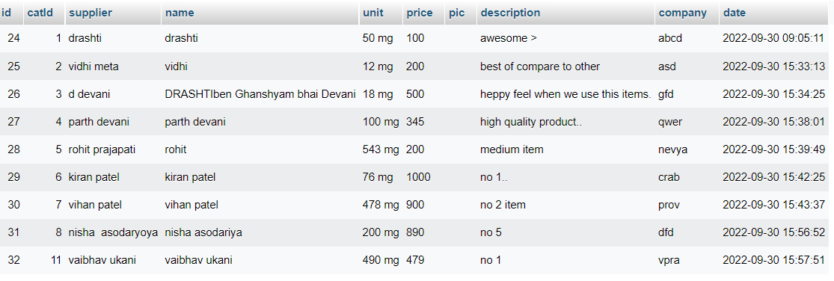

= site table :

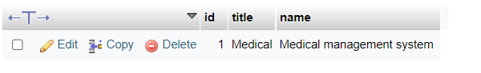

= sold table :

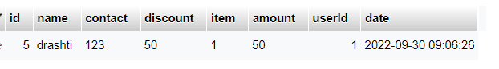

= supplier table :

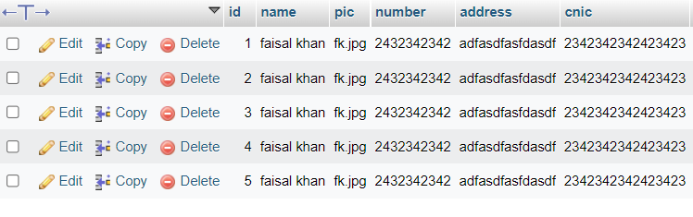

=users table :

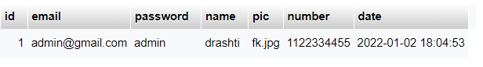

**6.2 Directory Structure :**

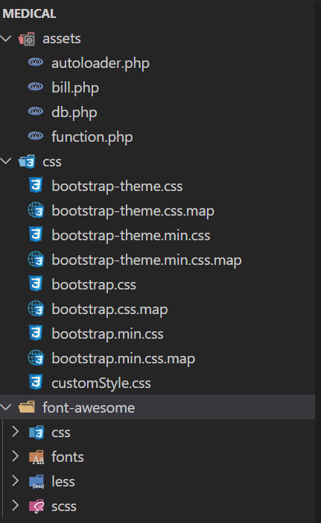

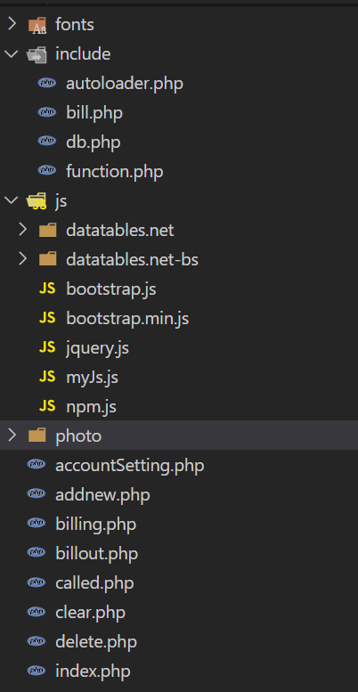

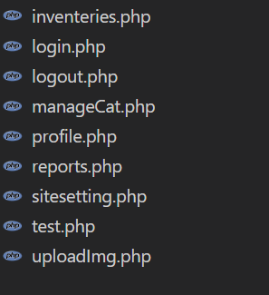

**6.3 : Input Design :**

* **Login page = Admin can login by using there email and password.**

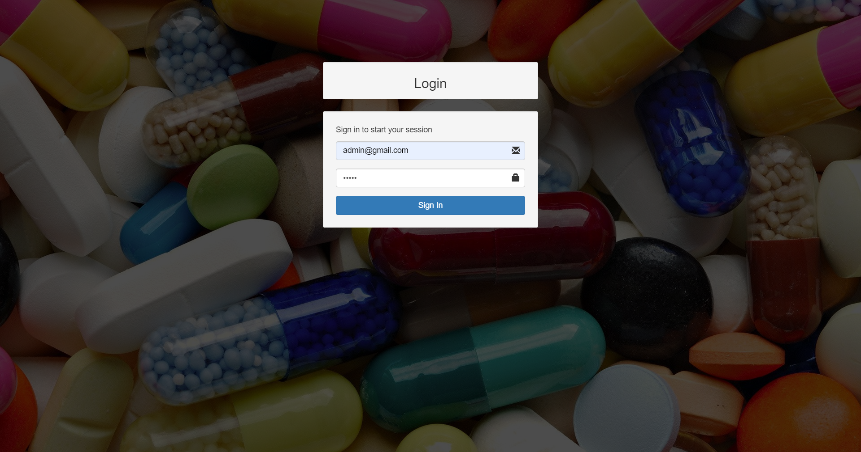

* **home page = admin can handle the product and home page.**

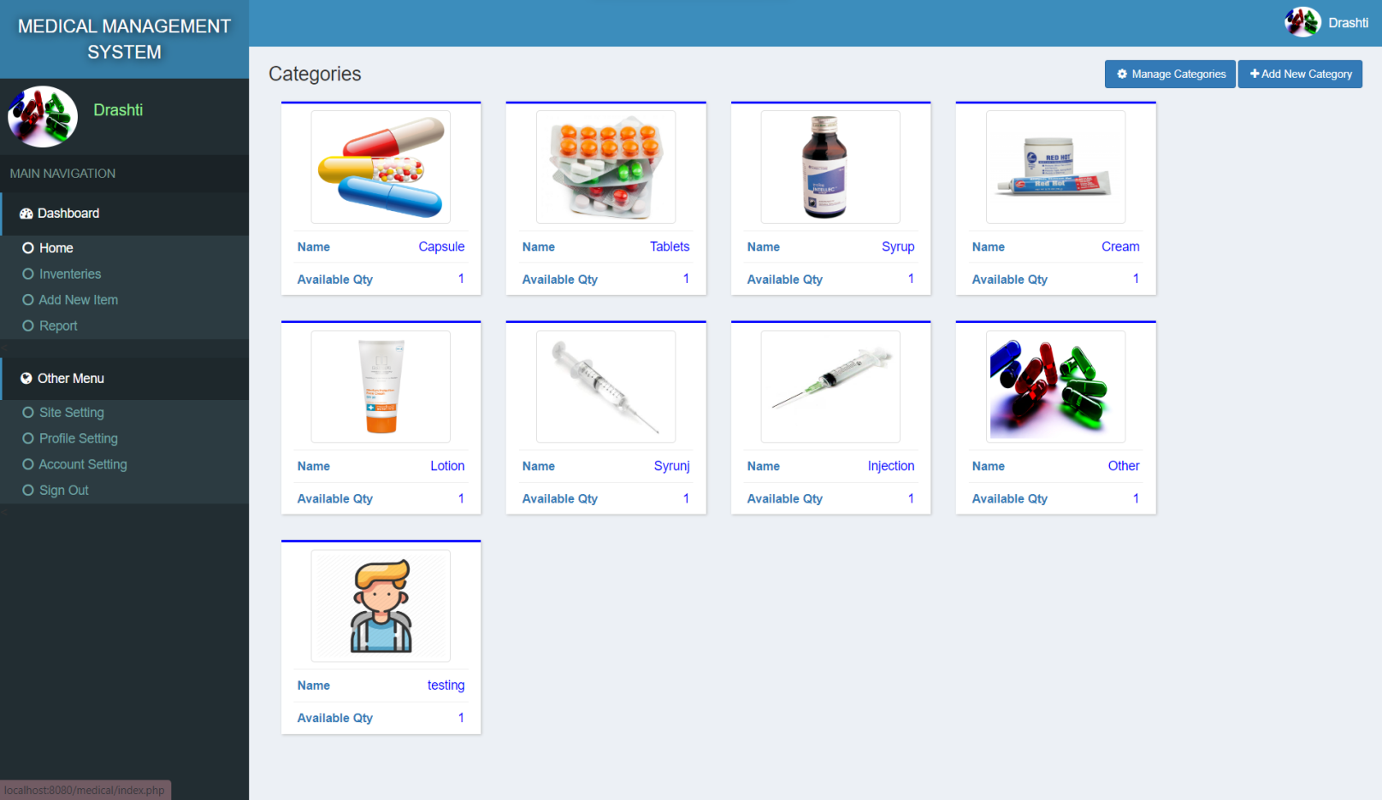

* **items = click the any product they can seen all details of the product.**

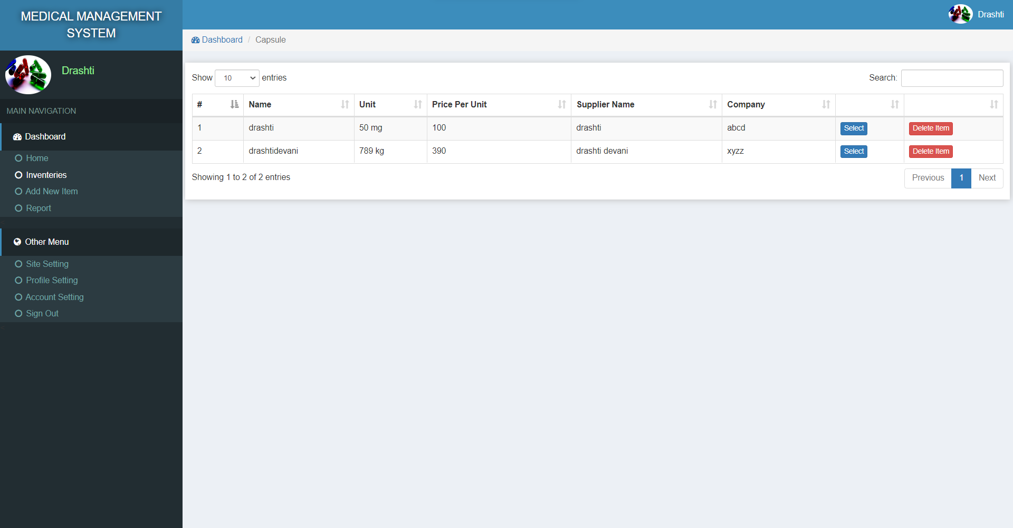

* **view bill page = admin can click the view bill button.**

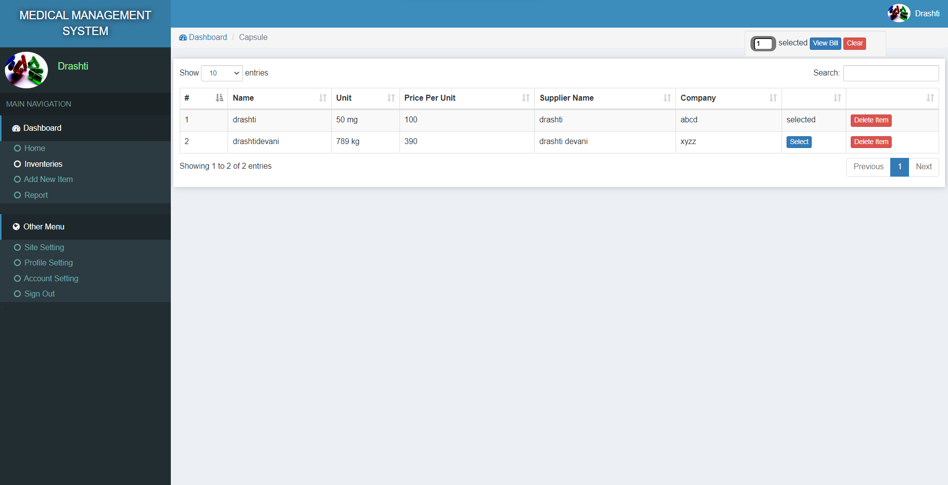

* **billing page = admin can update the product quality.**

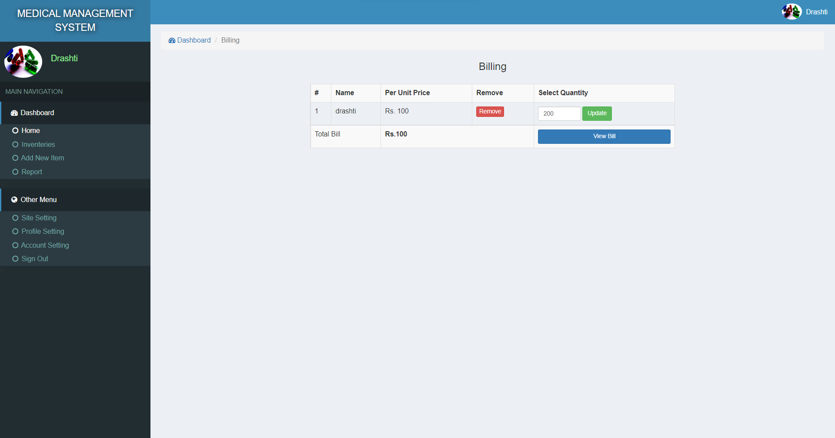

* **purchaser information page = admin can add ustomer name,contact,dis.**

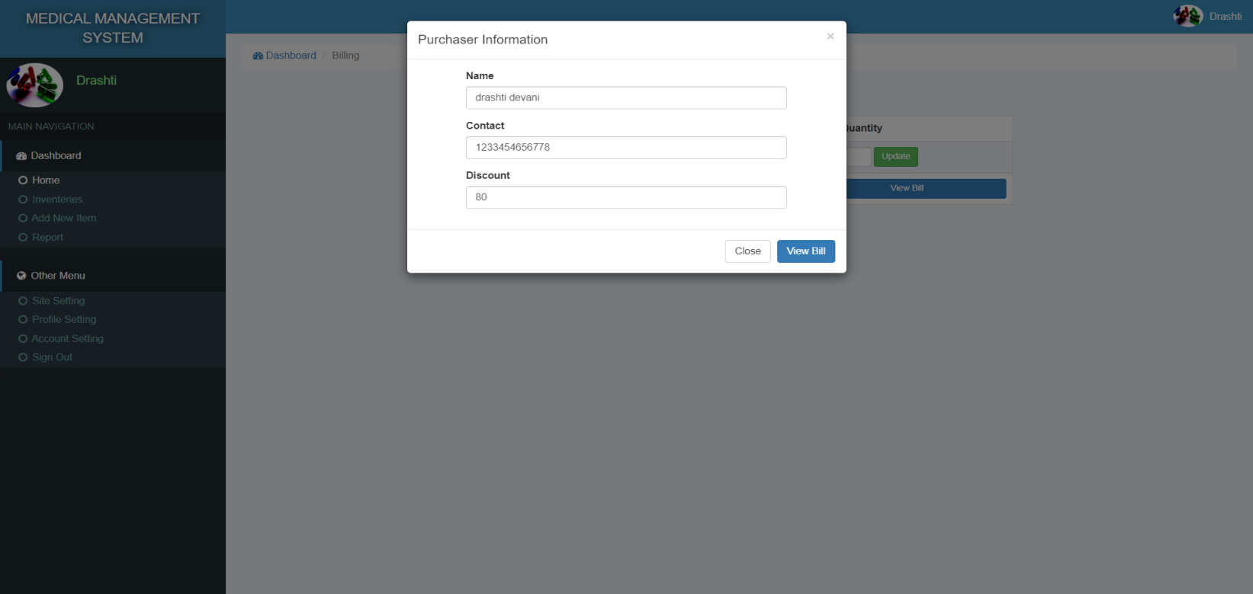

* **final bill page : lastly, admin can seen that bill and click the print button.**

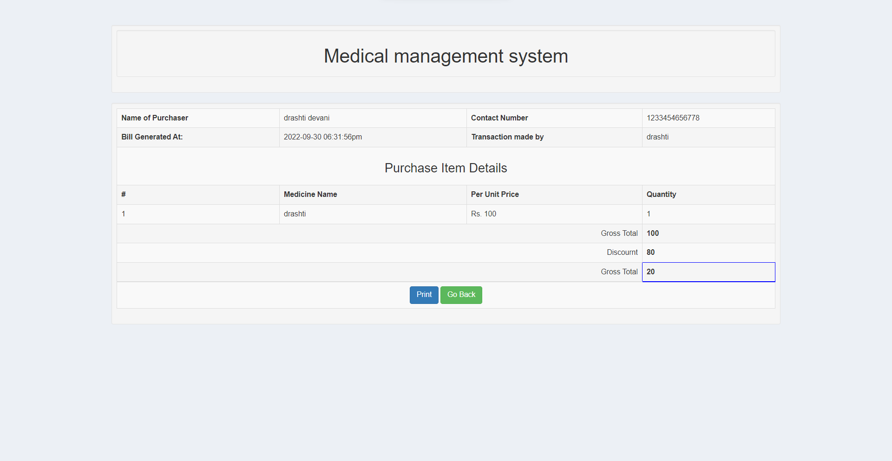

* **inventories page = admin seen the all the supplier and there full details.**

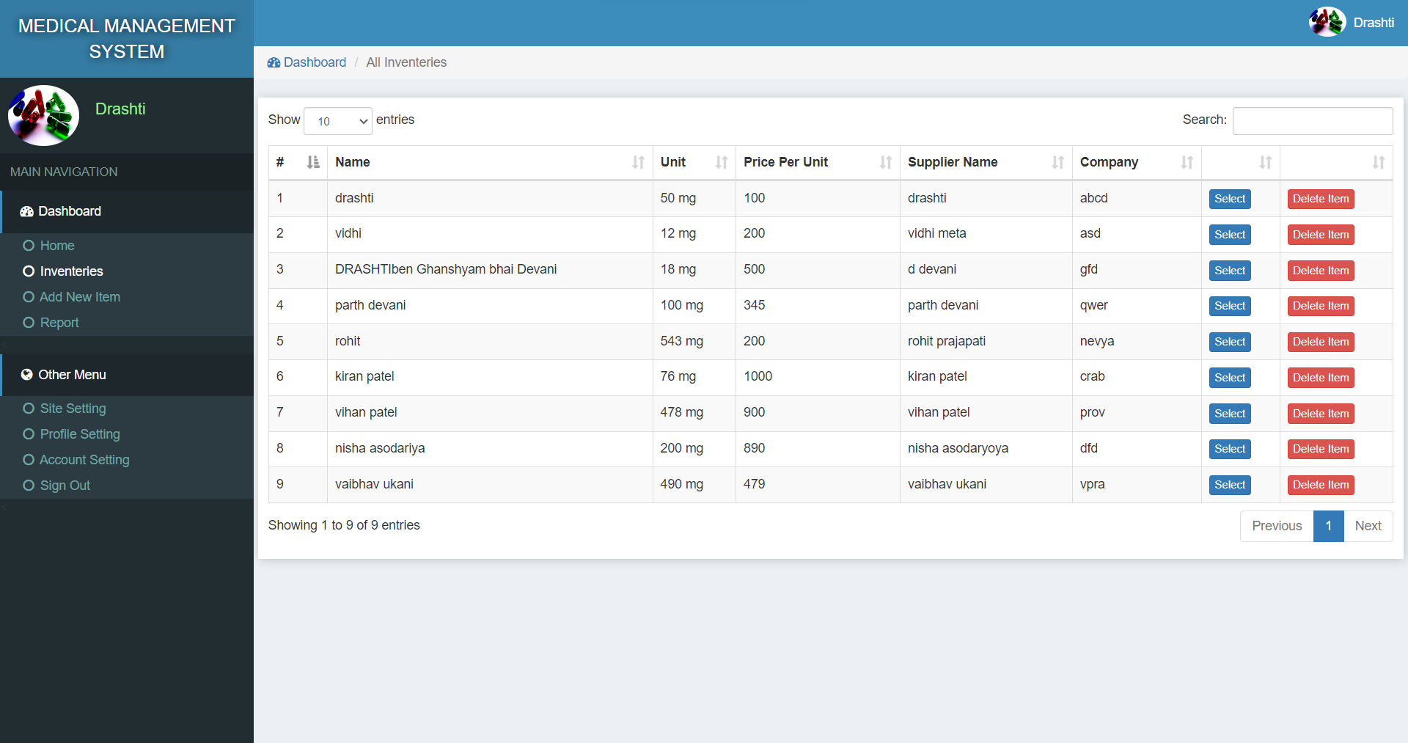

* **add new item page = admin can add the new items with the details.**

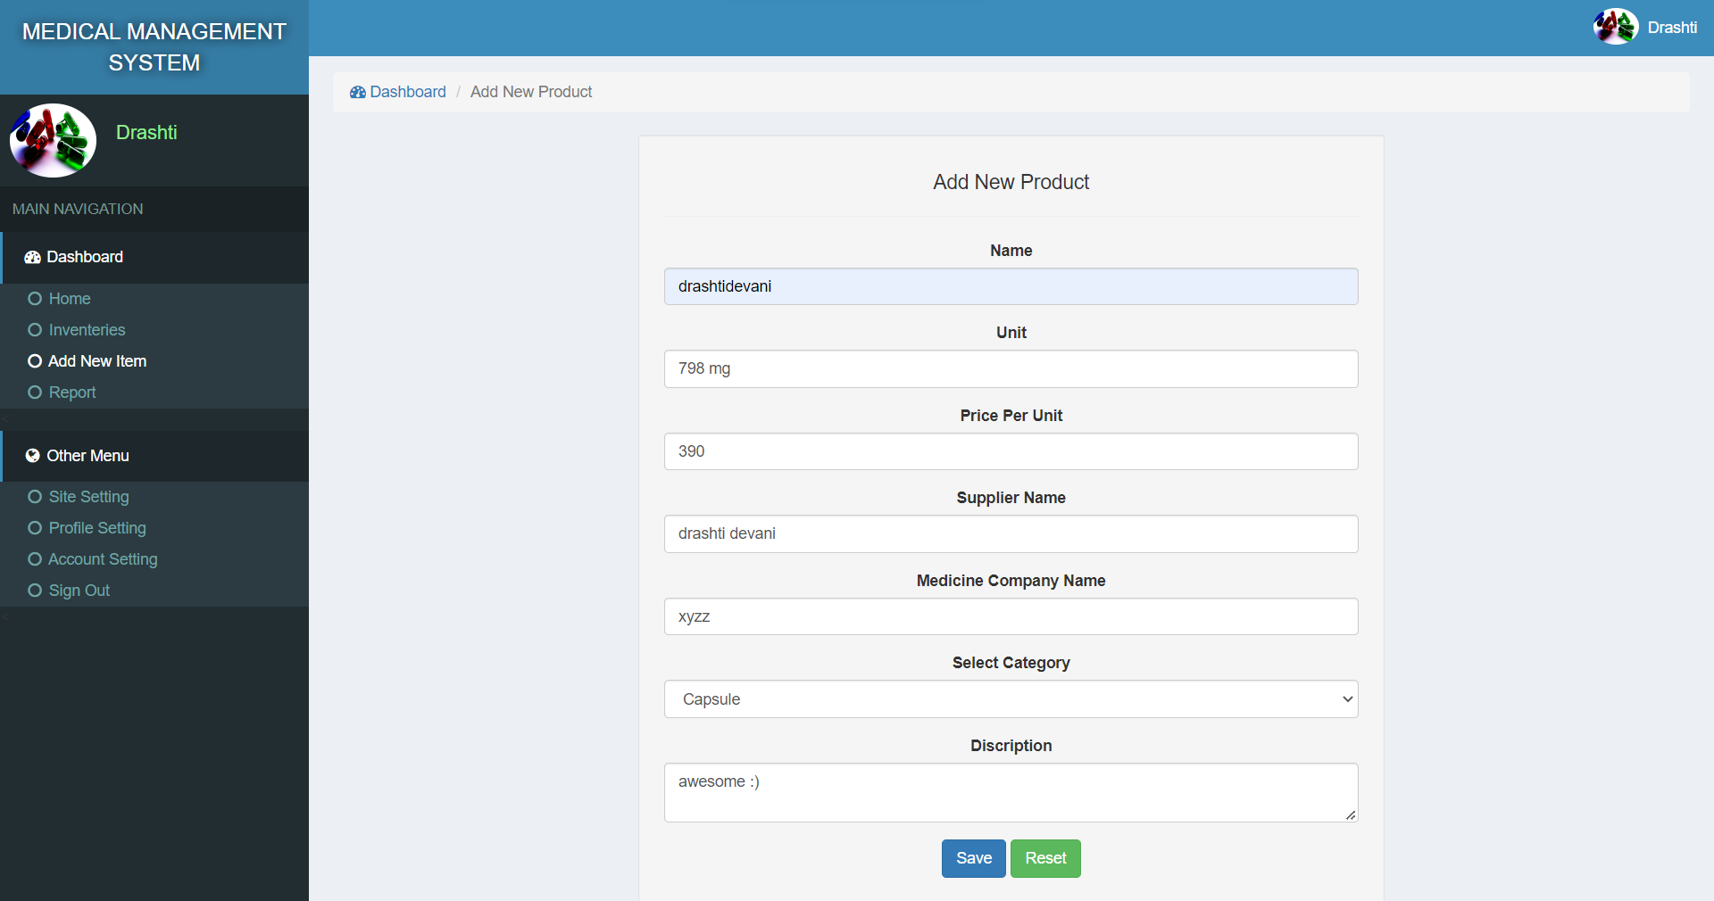

* **report page : admin can seen all the bill in the report page.**

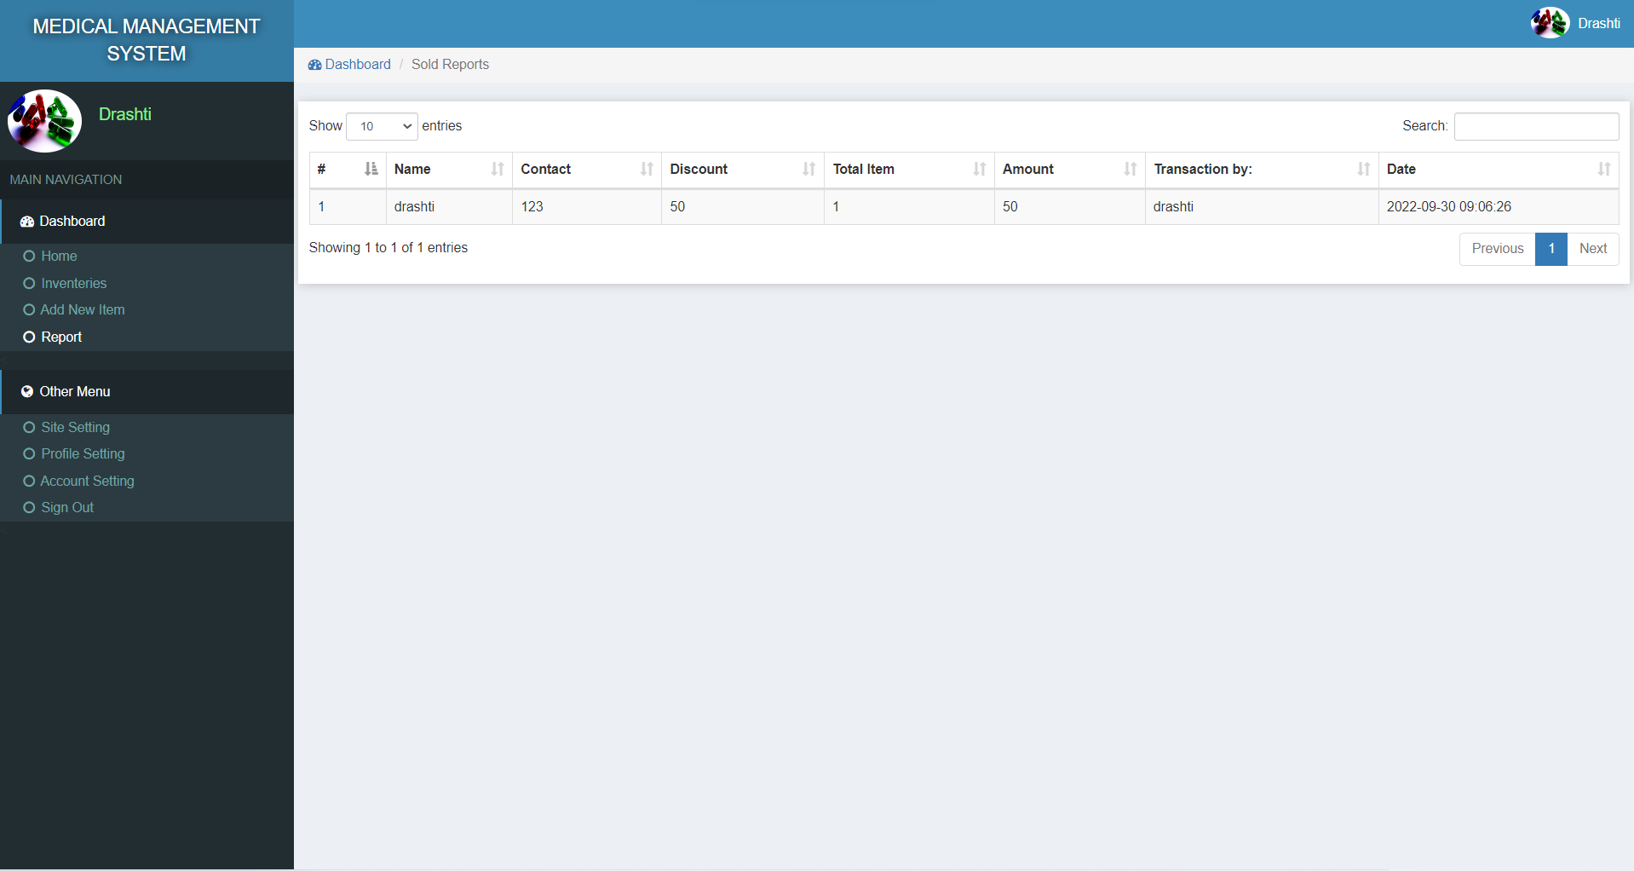

* **site setting page = admin can change the site title and name.**

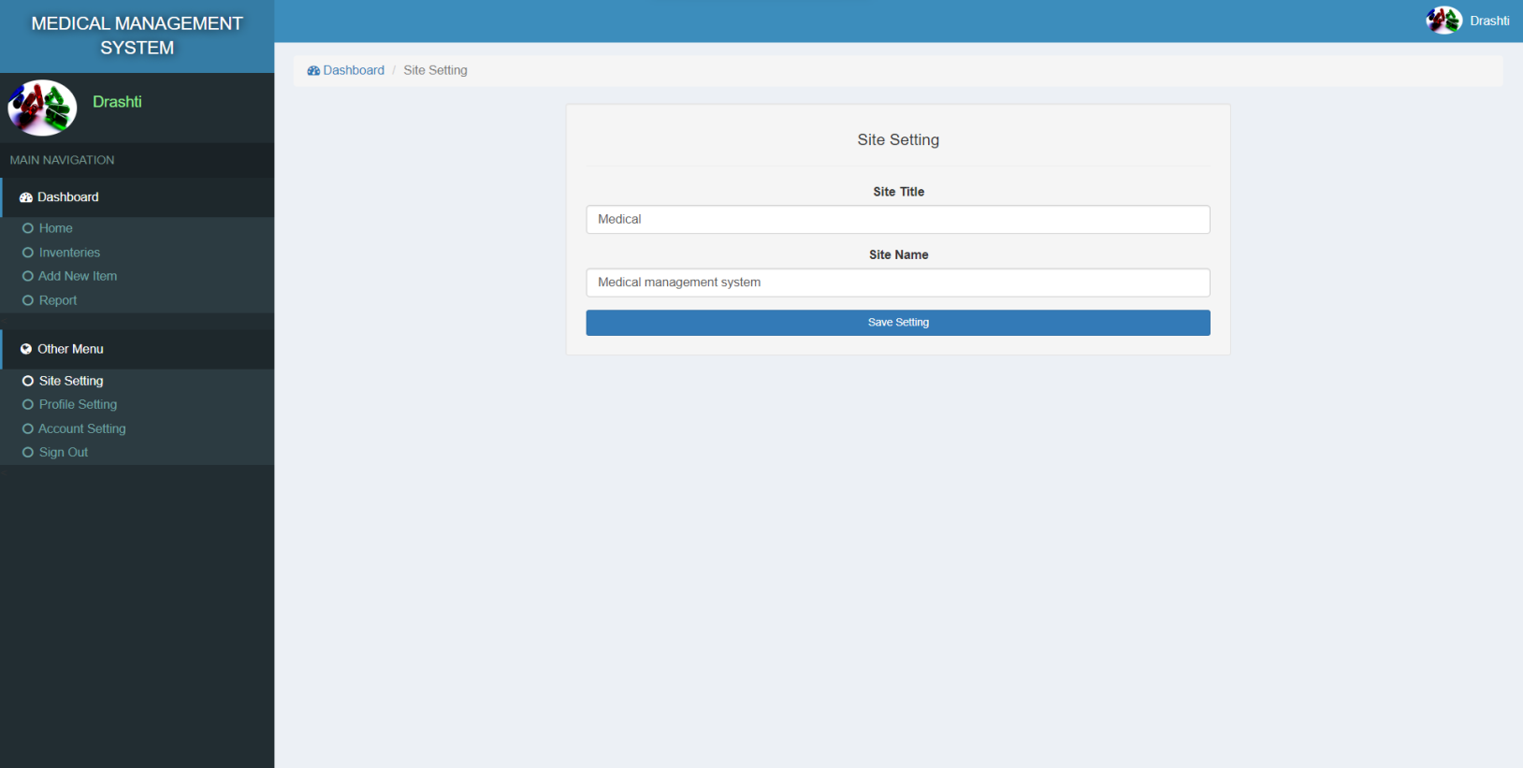

* **profile setting page = admin can change there profile.**

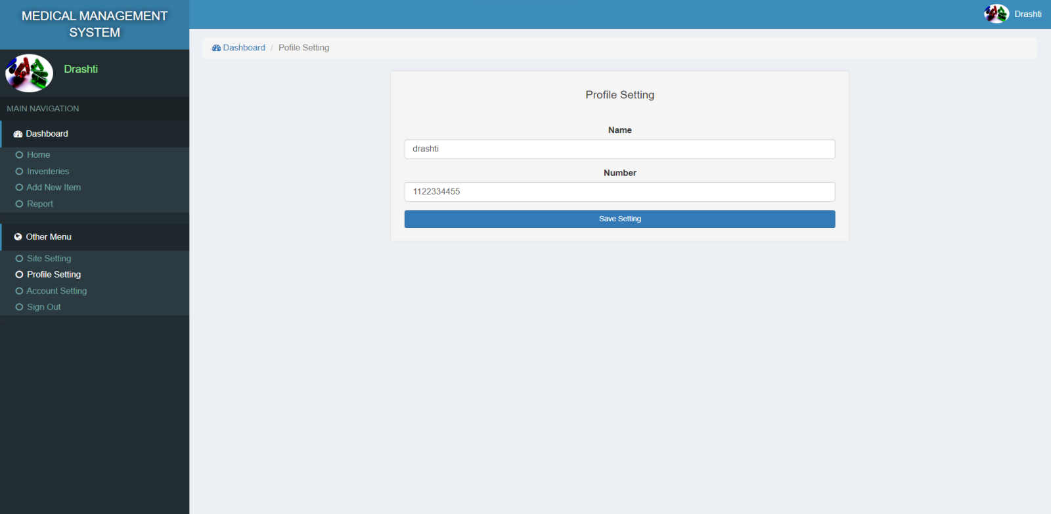

* **account setting page = admin can change there email and password.**

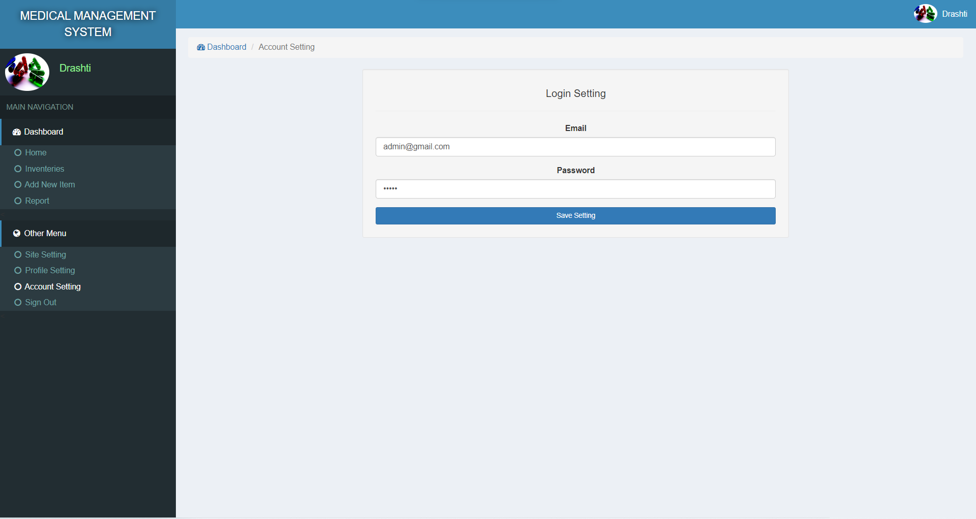

* **categories page = admin can edit the all medicine and items.**

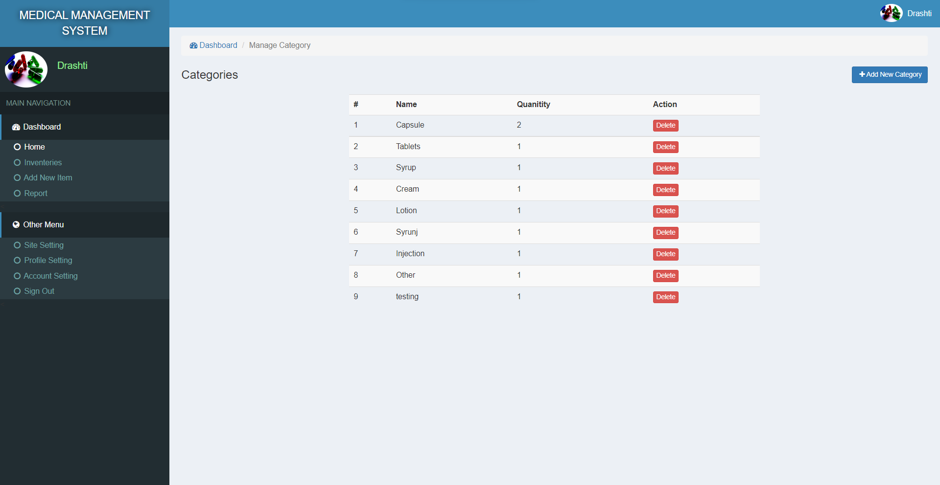

* **add new inventory page = admin can add the new inventory there choice**

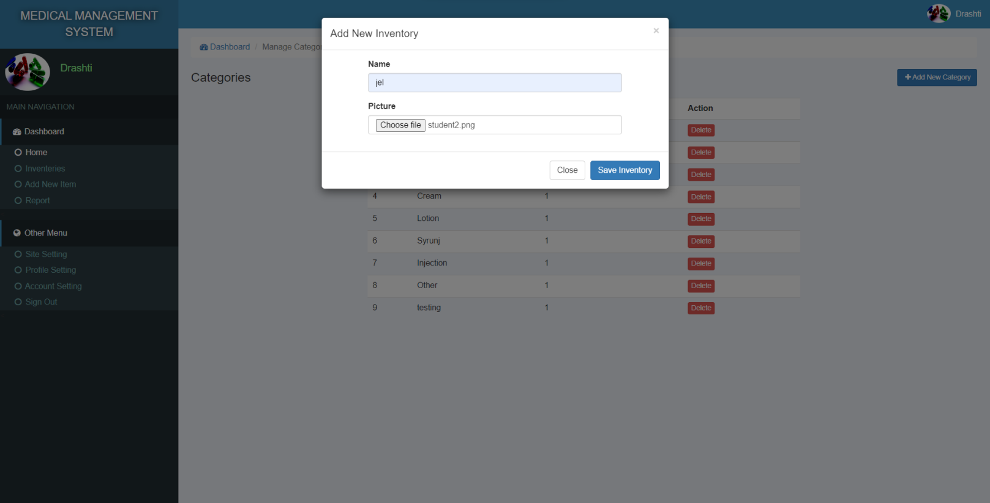

* **profile and logout = when admin click these buttons directly logout.**

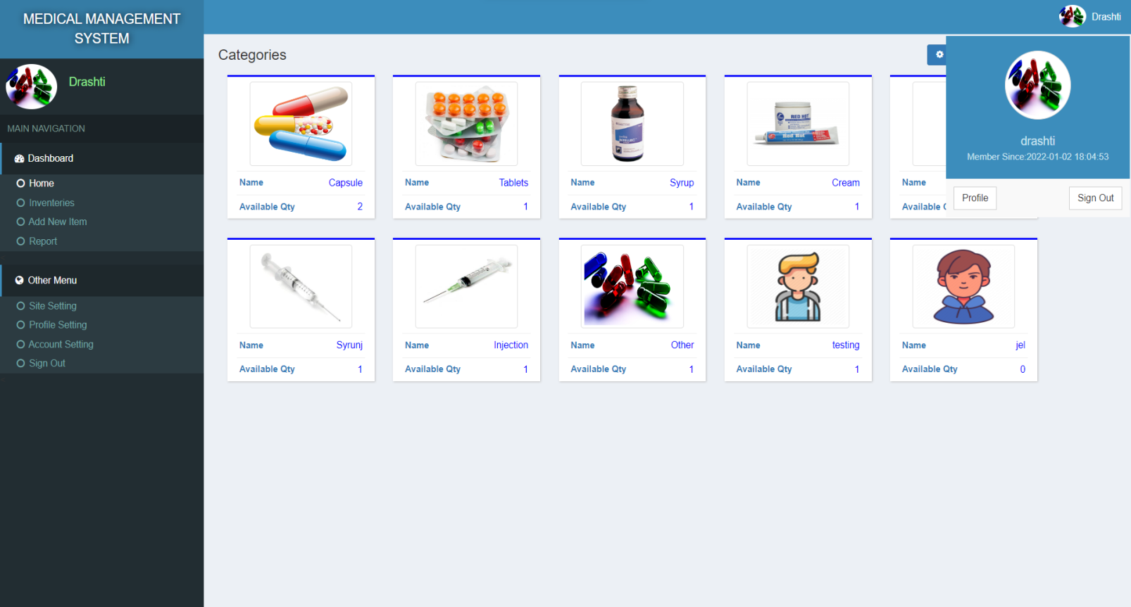

**6.4 : Output Design :**

* **home = added to the jel product in home page.**

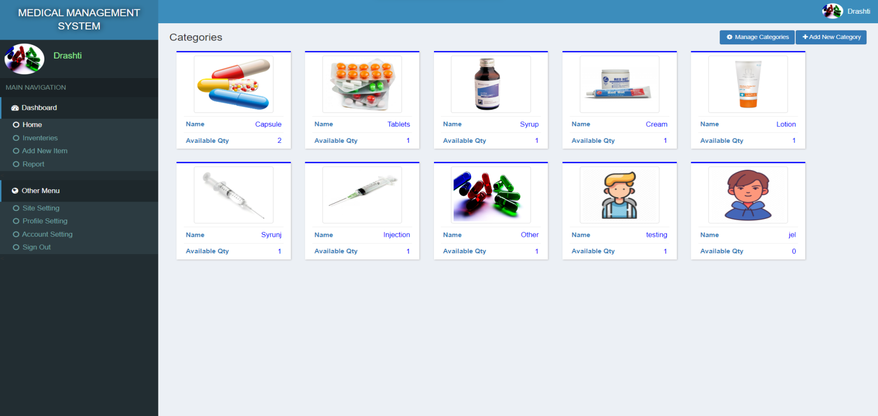

* **inventories = drashti devani last record added.**

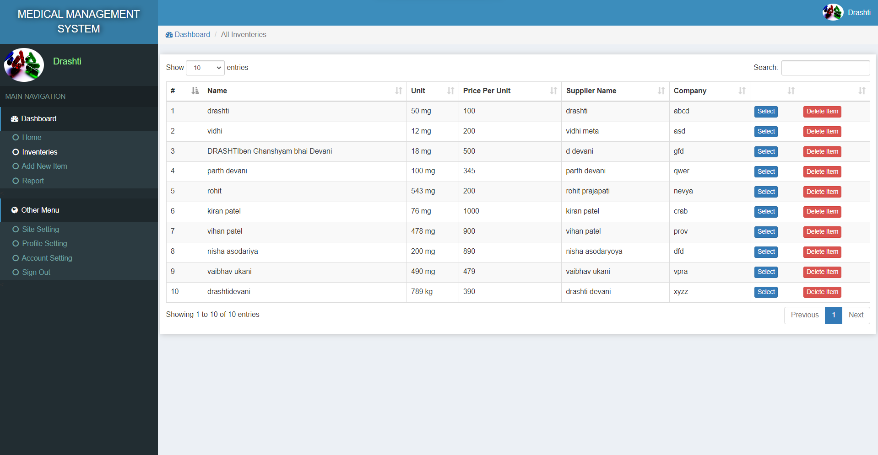

* **add new item = record added successfully.**

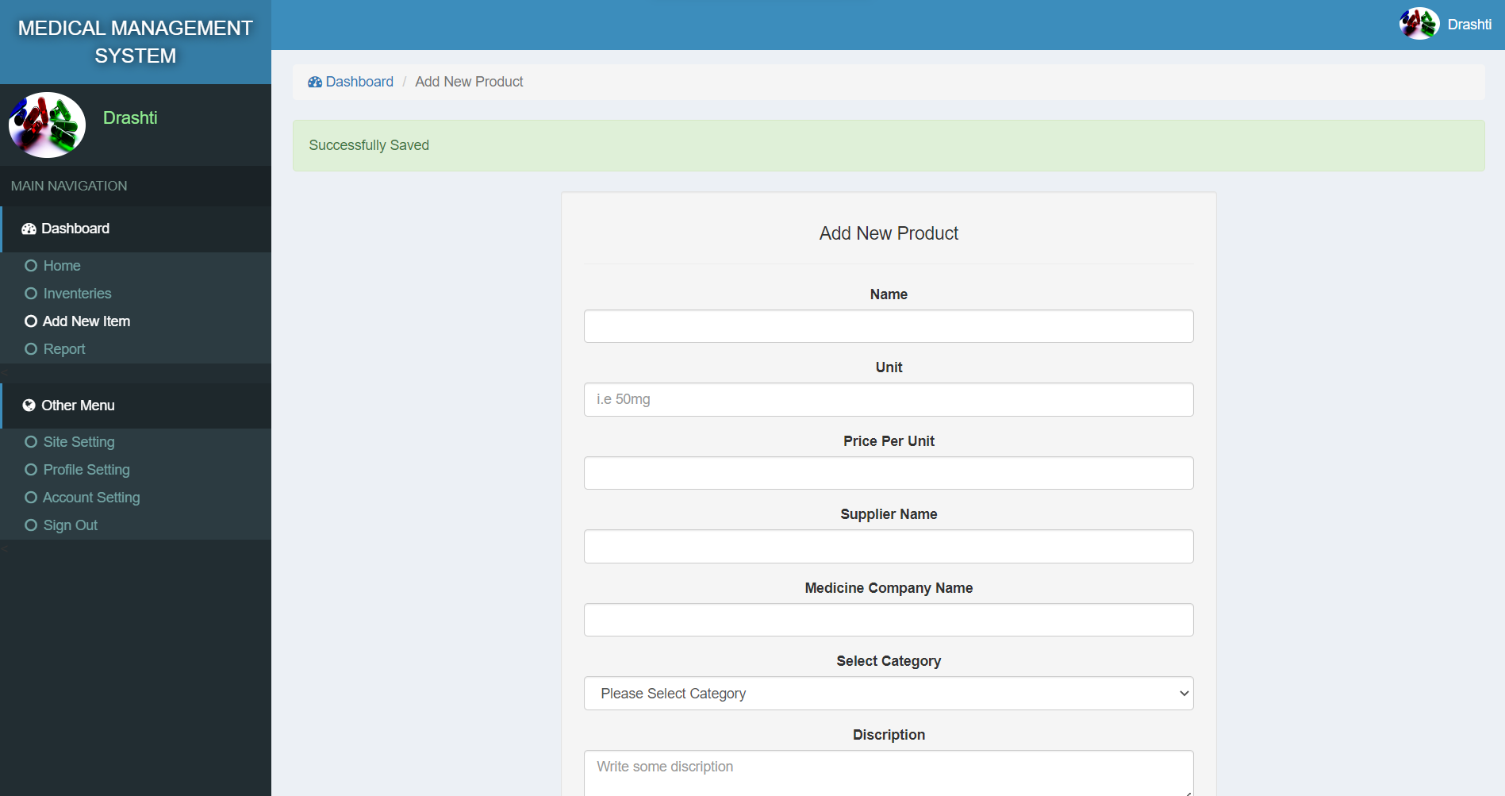

* **report = drashti ‘s bill created successfully.**

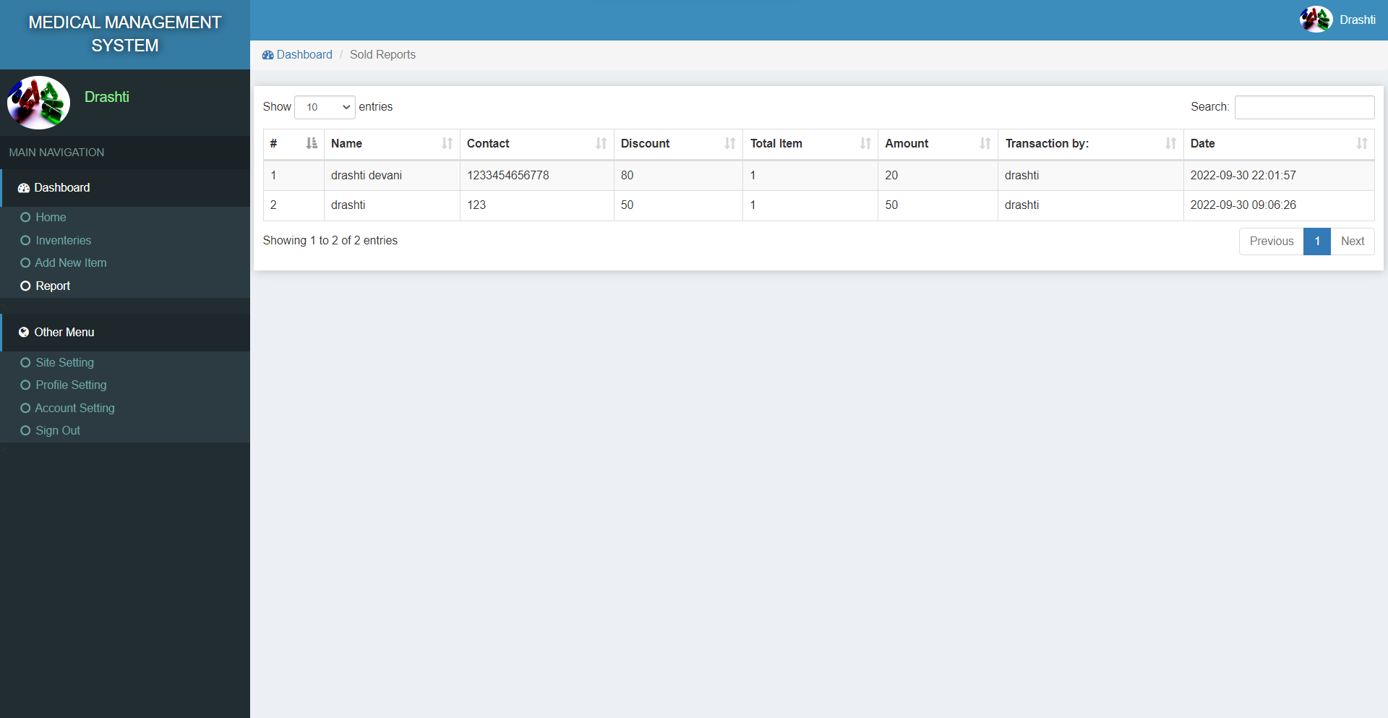

* **manage categories = jel added successfully in the recod.**

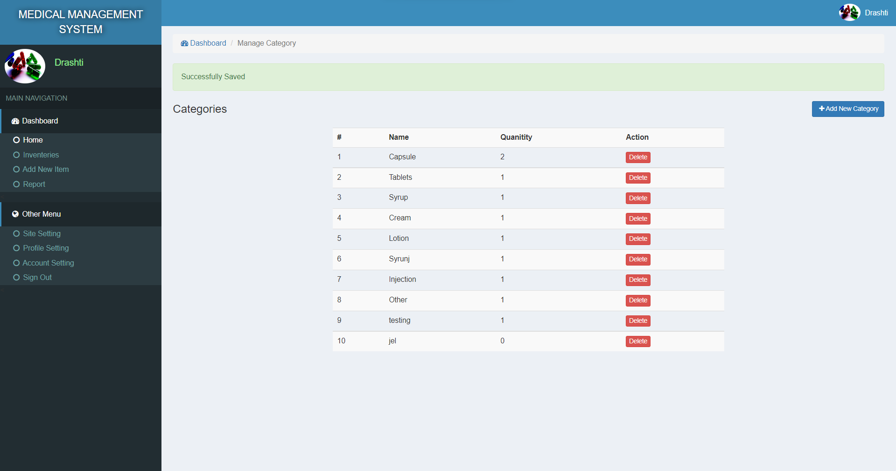

**7. Software testing :**

|  |  |  |
| --- | --- | --- |
| **Link** | **Expected page** | **Result page** |
| Admin_login | Admin_login | Admin_login |
| Dashbord | Dashbord page | Dashbord page |
| Home | Home page | Home page |
| Inventories | Inventories page | Inventories page |
| Add new item | Add new item | Add new item |
| Report | Report | Report |
| Site setting | Site setting | Site setting |
| Profile setting | Profile setting | Profile setting |
| Account setting | Account setting | Account setting |
| Manage categories | Manage categories | Manage categories |
| Add new categories | Add new categories | Add new categories |
| Logout | Logout | Logout |

* every module is working properly so no need to any changes in this medical management project.
* Every every like working proper.

**8 . Limitations and Future Scope of Enhancements :**

1. **Aim of the project:** The medical store management system is a generic software which can be used in an array of the outlets that is wholesalers and retailers for automating process of the manual record keeping mainly relevant to the cash flows and stocks. The aim of this project is to design and develop the software which provide ease ad improvement from the manual inventory system used by the medical stores.
2. **Objective of the project:** The objective of this project is to organize the medical store details like stocks, medicines, expense, sales and others. The project s mainly developed at the administrative end and therefore it onlyprovidesaccess to the administrator of the store. The medical store management system is developed as application program for reducing manual work managing medical store, it also helps in keeping track of all the details regarding the expense, stocks and sales.

**9 . References :**

* + <https://www.w3schools.in/>
  + <https://www.udemy.com/>
  + <https://www.youtube.com/>
  + <https://fontawesome.com/>
  + <https://codester.com/>
  + <https://greatlearning.com/>